# Requirements Statement

Now in this program we are going to calculate the multiple regression for a project set (added code, reused code, modified code).

For each test we will have a ste of historical data and a new project.

Will be 2 test.

## Test 1

**User_input** = [185,150,45]

**HIstorical data**

|  |  |  |  |  |
| --- | --- | --- | --- | --- |
| Prog. # | **Added LOC** | **Reused LOC** | **Modified LOC** | **Hours** |
|  | ***w*** | ***x*** | ***y*** | ***z*** |
| 1 | 345 | 65 | 23 | 31.4 |
| 2 | 168 | 18 | 18 | 14.6 |
| 3 | 94 | 0 | 0 | 6.4 |
| 4 | 187 | 185 | 98 | 28.3 |
| 5 | 621 | 87 | 10 | 42.1 |
| 6 | 1 | 0 | 0 | 15.3 |

**Results**

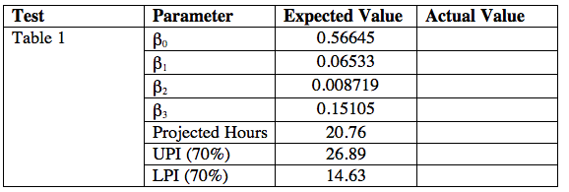

## Test 2

**User_input** = [650,3000,155]

**HIstorical data**

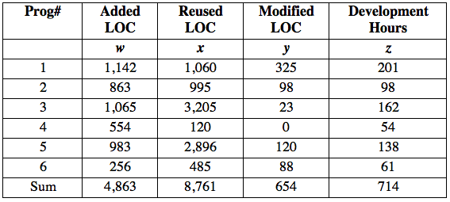

**Results**

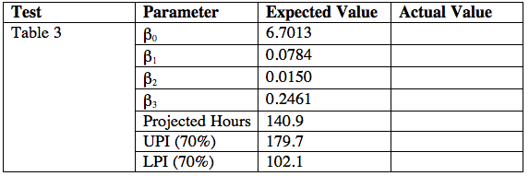

**To achieve this** we need to calculate multiple regression.

To calculate that we will have to use the next formula:

